During Kharif Season 2021-22 Progress of sowing and agricultural crops Details.
(18.09.2021)

2021-22 Agricultural Production:

Anticipating timely and well distributed rainfall during pre-monsoon, southwest & northeast monsoon period in 2021-22 it was programmed to cover 77.00 lakh hectares, 28.00 lakh hectares and 5.00 lakh hectares during Kharif, Rabi and Summer seasons respectively, totally 110.00 lakh hectares under agricultural crops. Proposed production target for Food grains and Oilseeds were 135.48 lakh tonnes and 15.23 lakh tonnes respectively.

Sl.No. | Crops | Area (Lakh Hectares) | Production (Lakh Tonnes)
1. | Cereals | 45.91 | 112.69
2. | Pulses | 33.84 | 22.79
 | Total Food Grains | 79.76 | 135.48
3. | Oilseeds | 15.08 | 15.23
4. | Commercial Crops
i) | Cotton | 7.77 | 21.37Lakh Bales
ii) | Sugarcane | 6.68 | 400.00
iii) | Tobacco-VFC | 0.71 | 0.64
 | -Beedi | 0.00 | 0.00
 | Total Area | 110.00

2021-22 Kharif Agricultural Production:

During Kharif 2021 total of 77.00 lakh hectares area has been set as target for sowing under different crops.
Sl.No. | Crops | Area (Lakh Hectares) | Production (Lakh Tonnes)
1. | Cereals | 31.37 | 87.73
2. | Pulses | 21.07 | 14.16
 | Total Food Grains | 52.44 | 101.88
3. | Oilseeds | 10.67 | 10.85
4. | Commercial Crops
i) | Cotton | 7.30 | 21 Lakh Bales
ii) | Sugarcane | 5.88 | 400.00
iii) | Tobacco-VFC | 0.71 | 0.64
 | -Beedi | 0.00 | 0.00
 | Total Area | 77.00

During pre-monsoon period between April to May in view of agricultural activities in the state, districts such as chamarajanagara, mandya, hassan, chikkamangaluru, tumkur and chitradurga at various places land preparation as been done and till 30.05.2021 total of 3.06 lakh ha. area as been sown under jowar, greengram, blackgram, cowpea, sesamum, sunflower, cotton, etc.

In Coastal, Malnad, South Interior Karnataka and North Interior Karnataka region, after south west monsoon commenced land preparation and sowing activities have been started.

Rainfall:

During 2021-22 normal Pre-monsoon rainfall (March-1 to May-31) was 115 mm against actual rainfall 166 mm (44 %).

Southwest monsoon (June-1 to September-13) normal average rainfall was 779 mm against actual rainfall 737 mm.(-5%).

September (18.09.2021) normal average rainfall was 6 mm against actual rainfall 0 mm.(-96%).

Kharif 2021 Area coverage:
During Kharif 2021 total of 76.97 lakh hectares (99.96%) has been sown against a set target of 77.00 lakh hectares by 18.09.2021, Cropwise and districtwise area sown details was provided in annexure 2 and 3.

Seeds:

For Kharif 2021-22, 6.00 lakh qtls seeds were estimated as demand for sowing and till dated:18.09.2021, 4.12 lakh qtls seeds have been distributed at Raitha Samparka Kendra (RSK). Remaining balance of 44179.21 qtls stock is available at RSK .

Fertilizer:

For Khrif 2021-22, total fertilizer demand was estimated at 26.47 lakh metric tonnes and arrangement has been made for timely implementation at various stages till 18.09.2021 total of 22.45 lakh metric tonnes fertilizer as been supplied and the available stock is 7.34 lakh metric tonnes.

Annexure-1
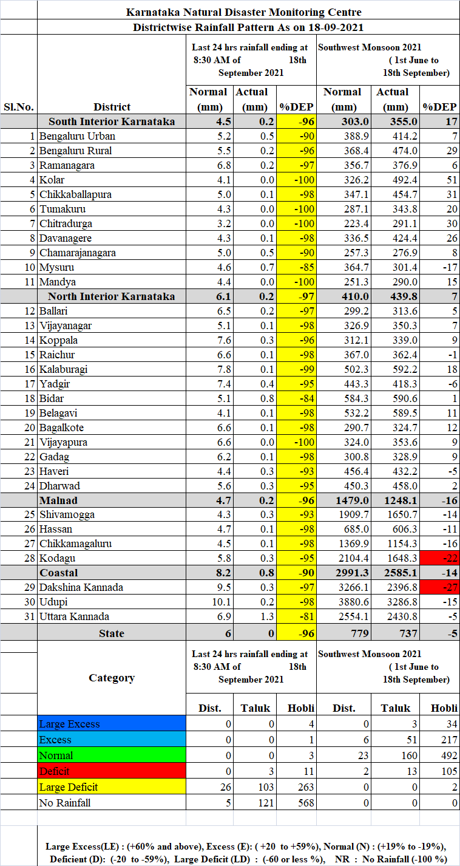

Annexure-2

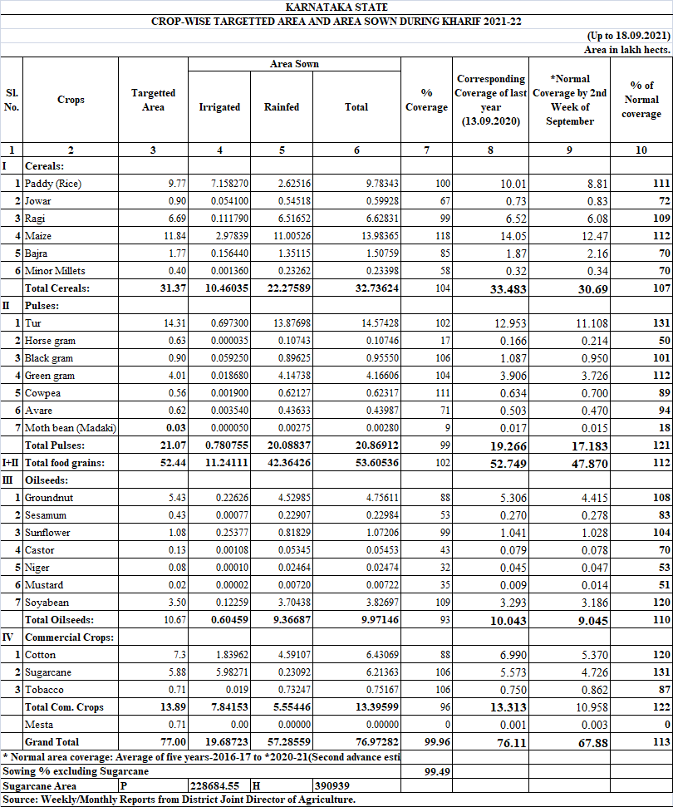

Annexure-3
